**Cloud Computing: UE20CS352**

**Assignment 2 – Jenkins (Creating a DevOps Pipeline, CI/CD tool)**

**-Adithya M, Section K**

**-PES1UG20CS621**

1. **Task 1**

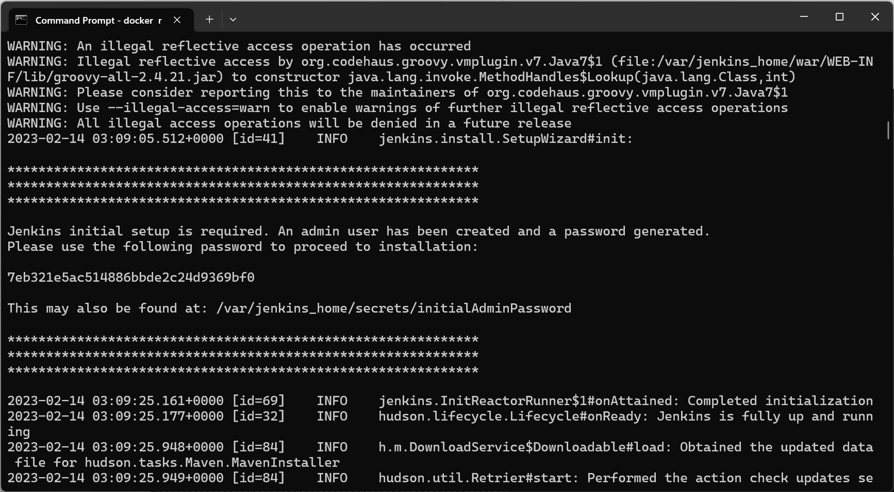

1. **Task 2**

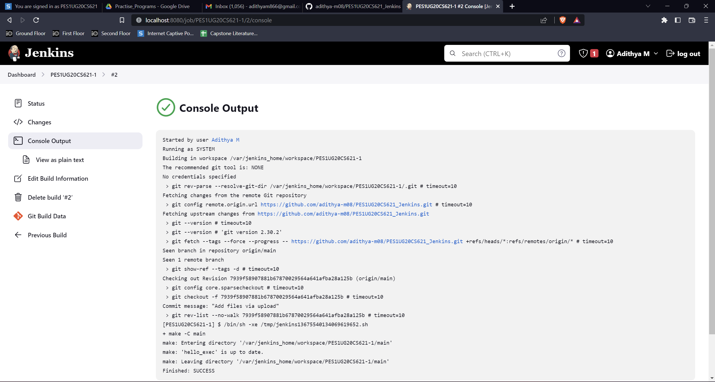

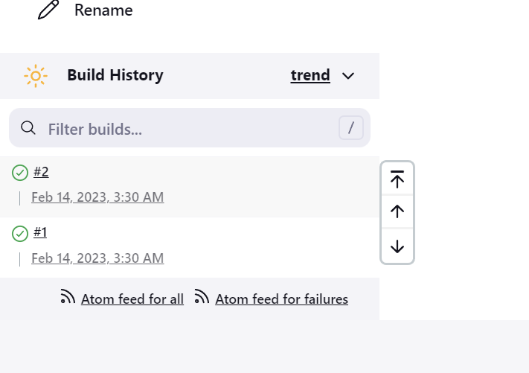

1. **Task 3:**

Console output of second job

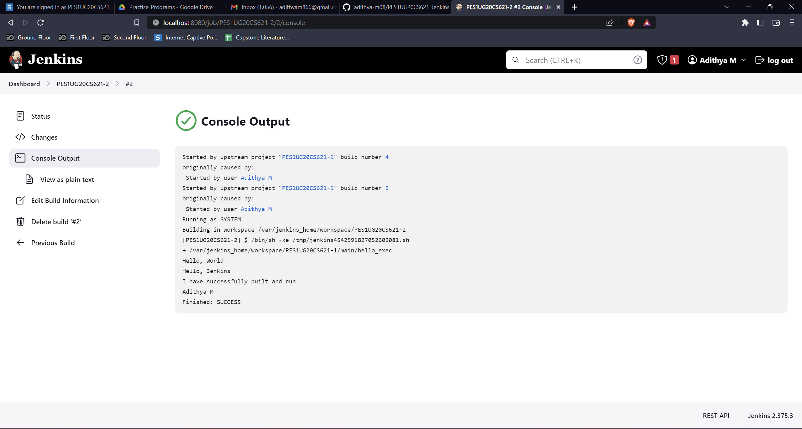

Status page of first job

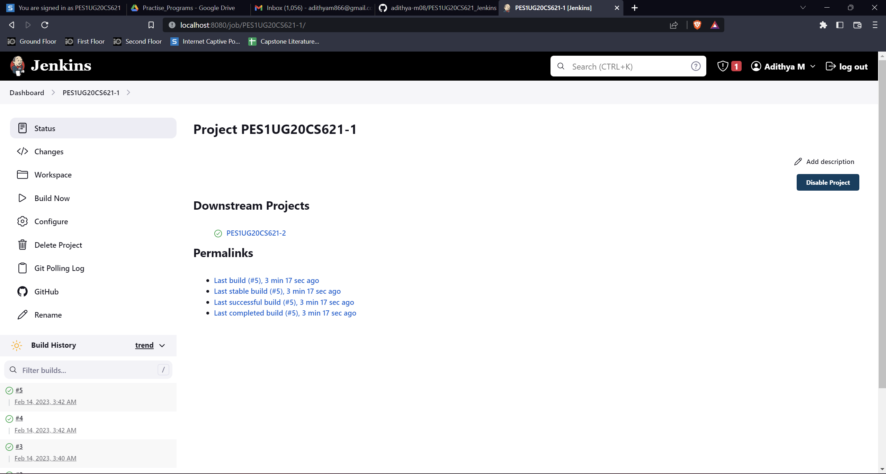

Build History of Jenkins

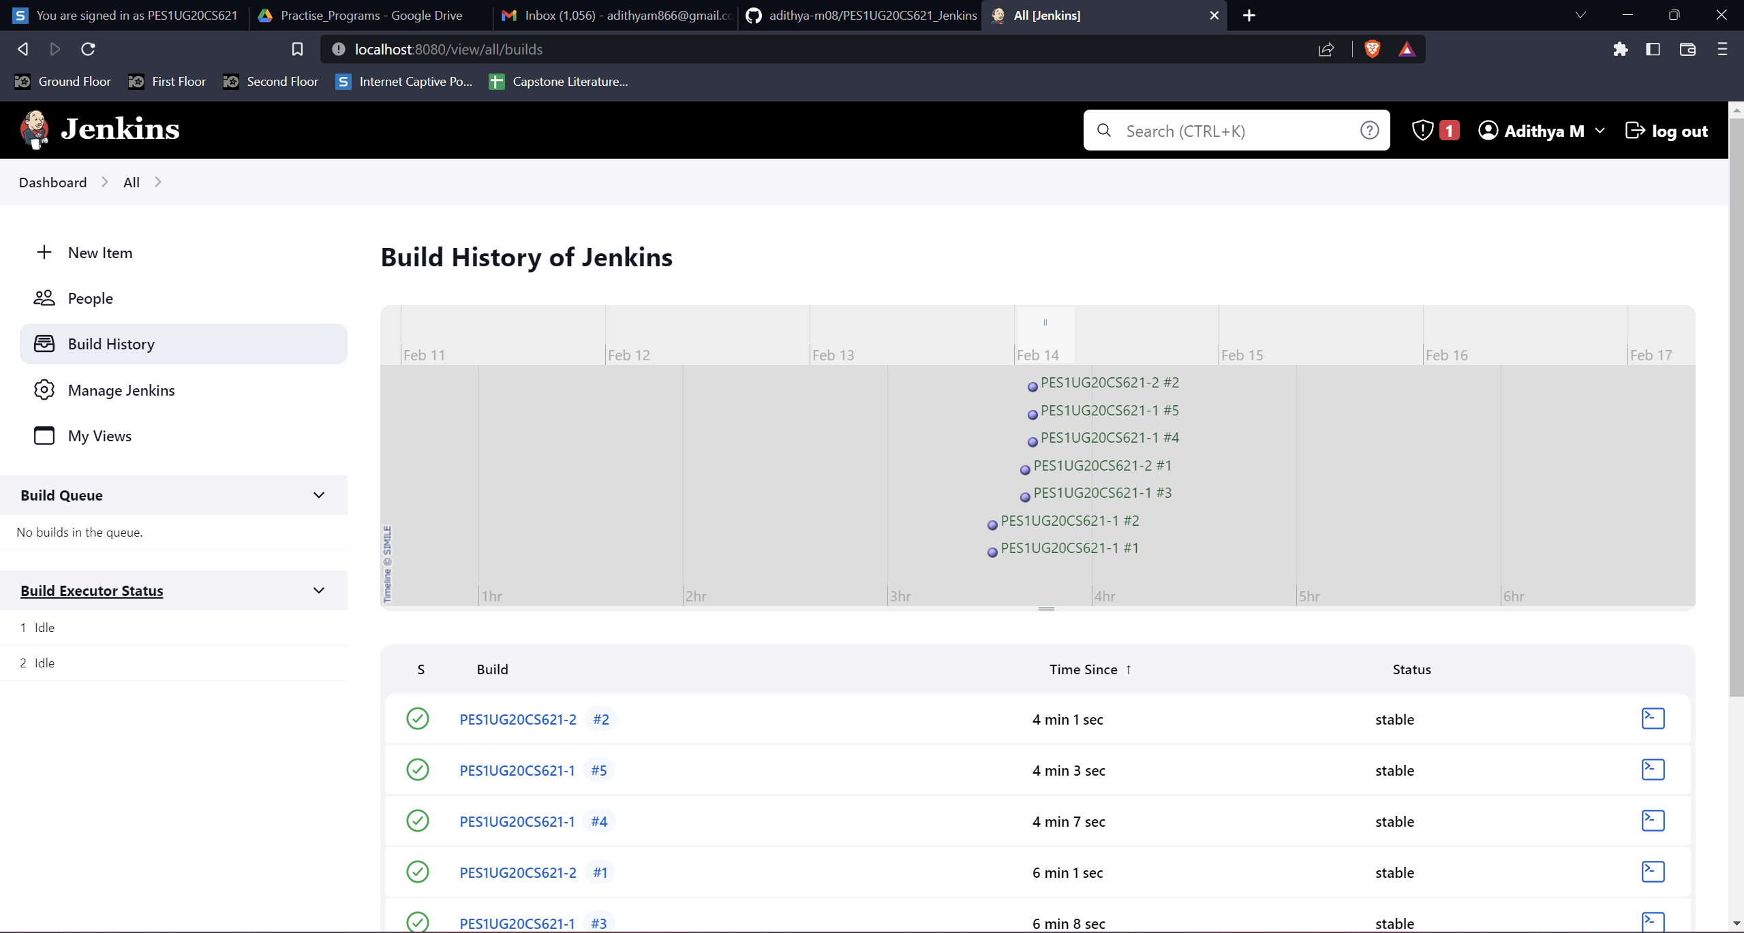

Jenkins Dashboard

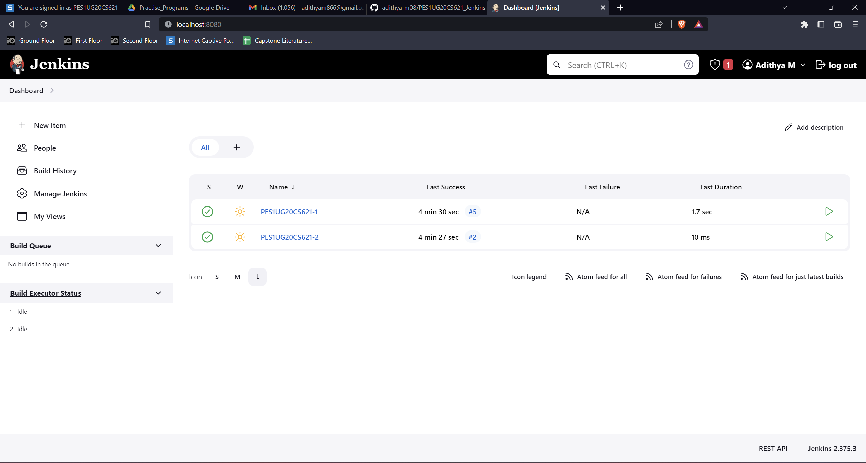

1. **Task 4**

Webhook added to your GitHub repository

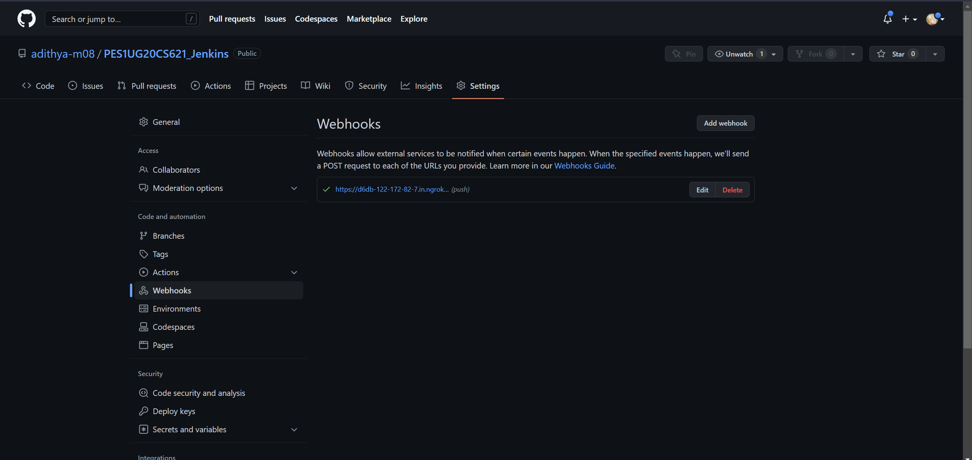

Console Output of second job displaying the change made in hello.cpp file

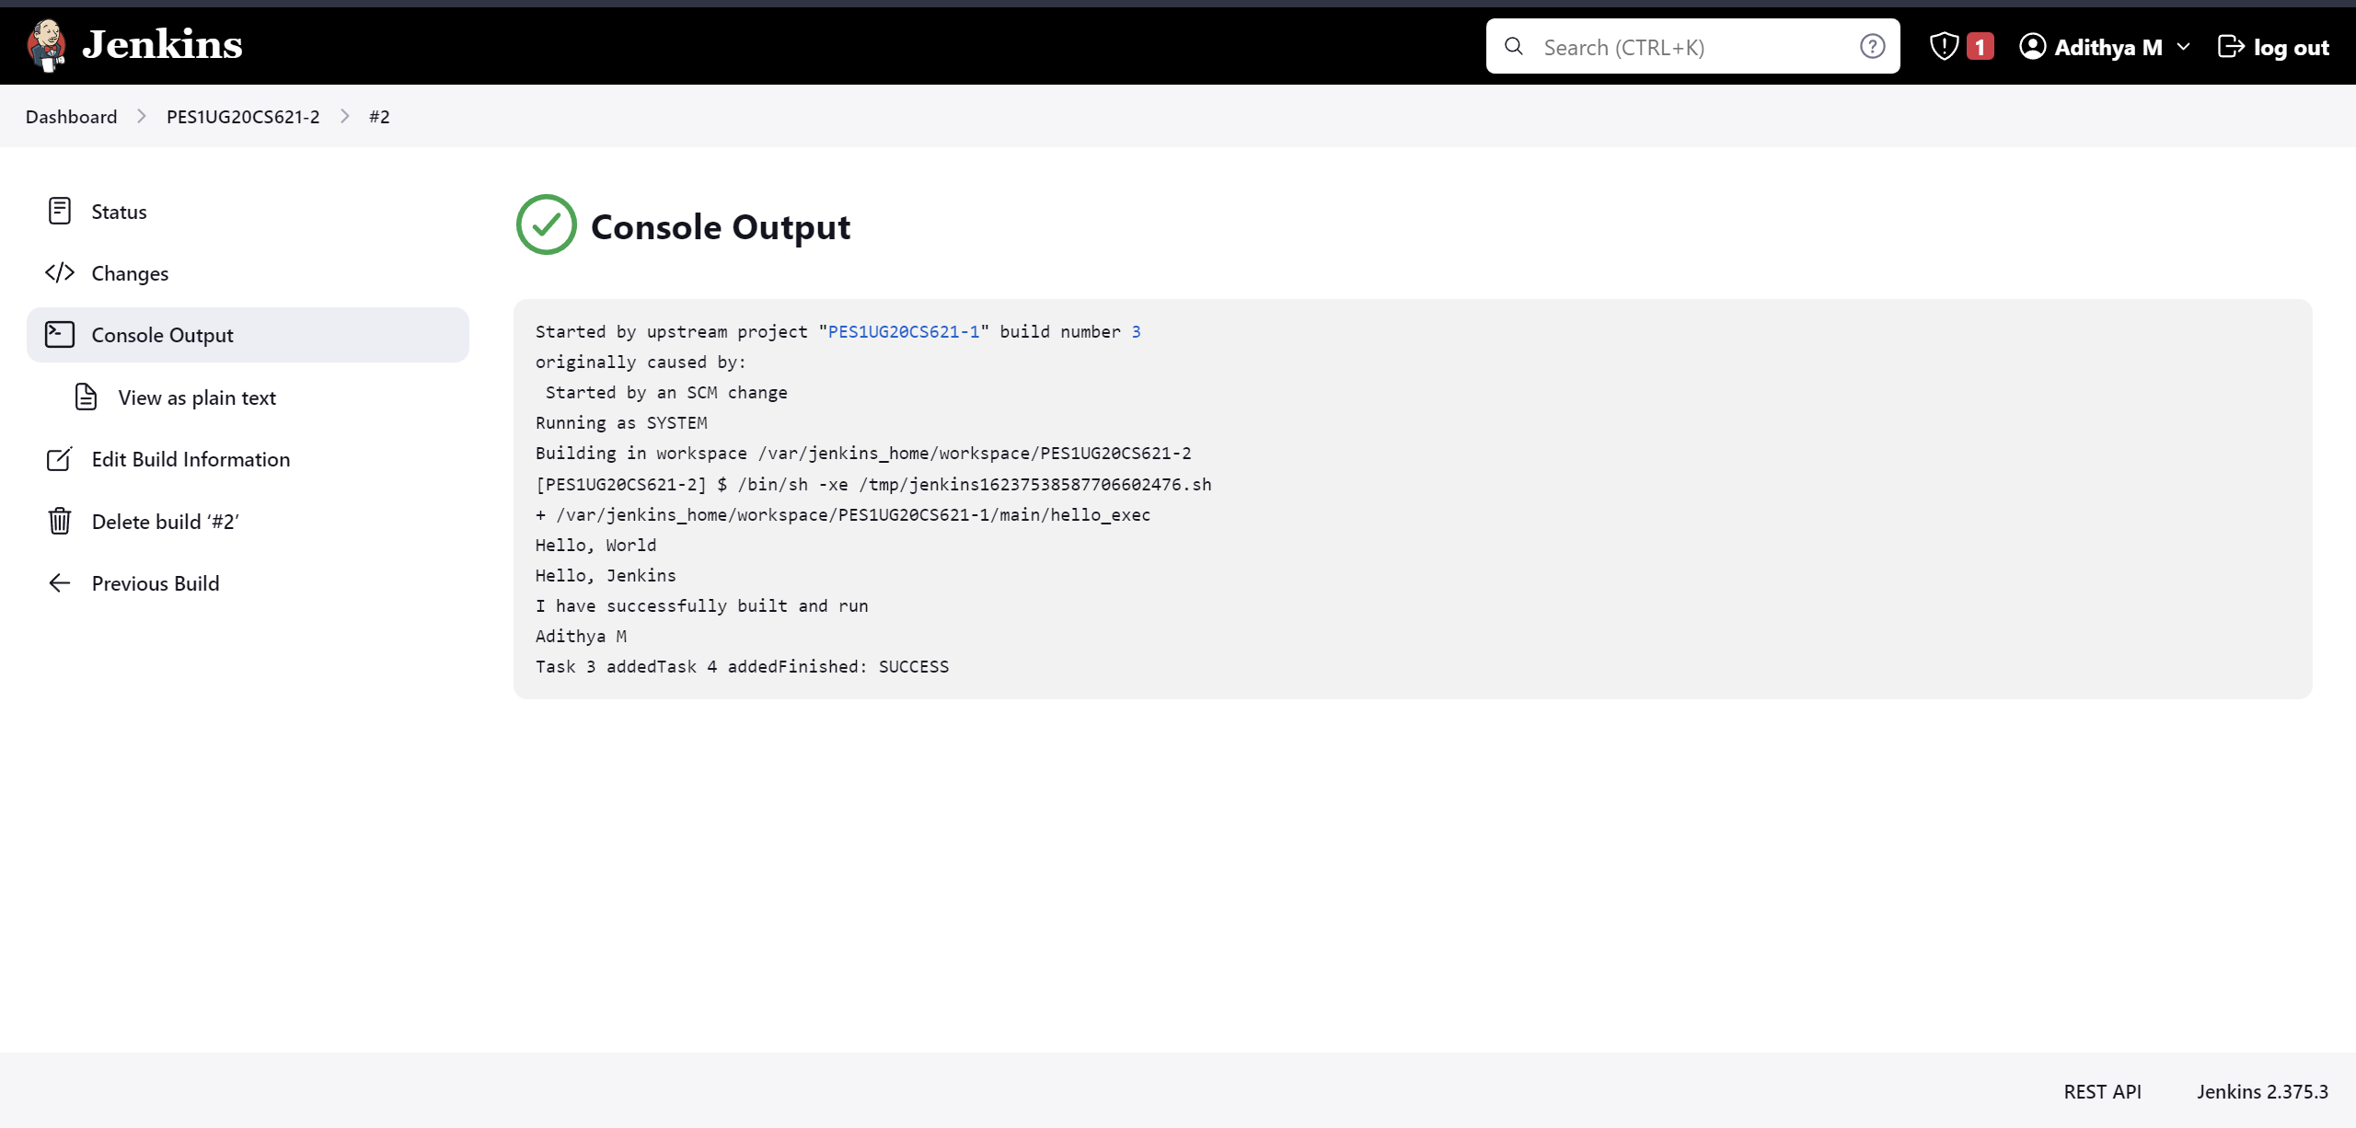

1. **Task 5:**

Code/script written to create basic pipeline using GitHub repository:

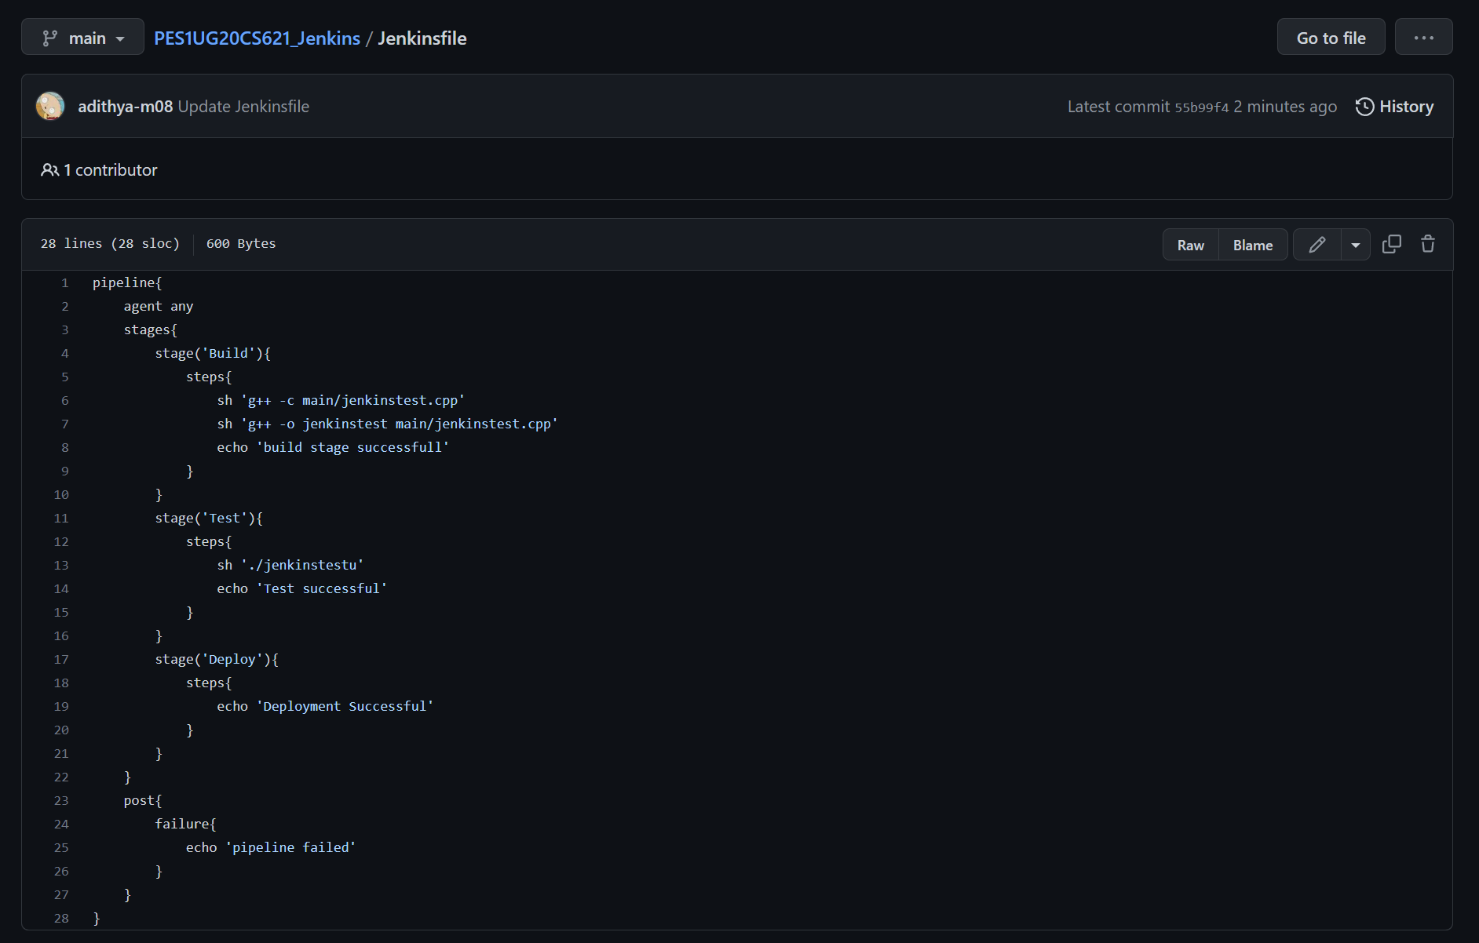

Stage View

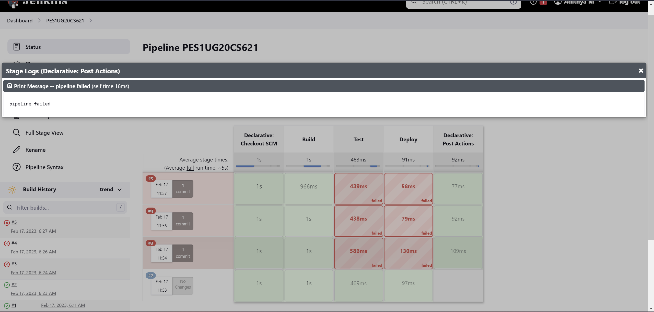

Console Output of the Pipeline:

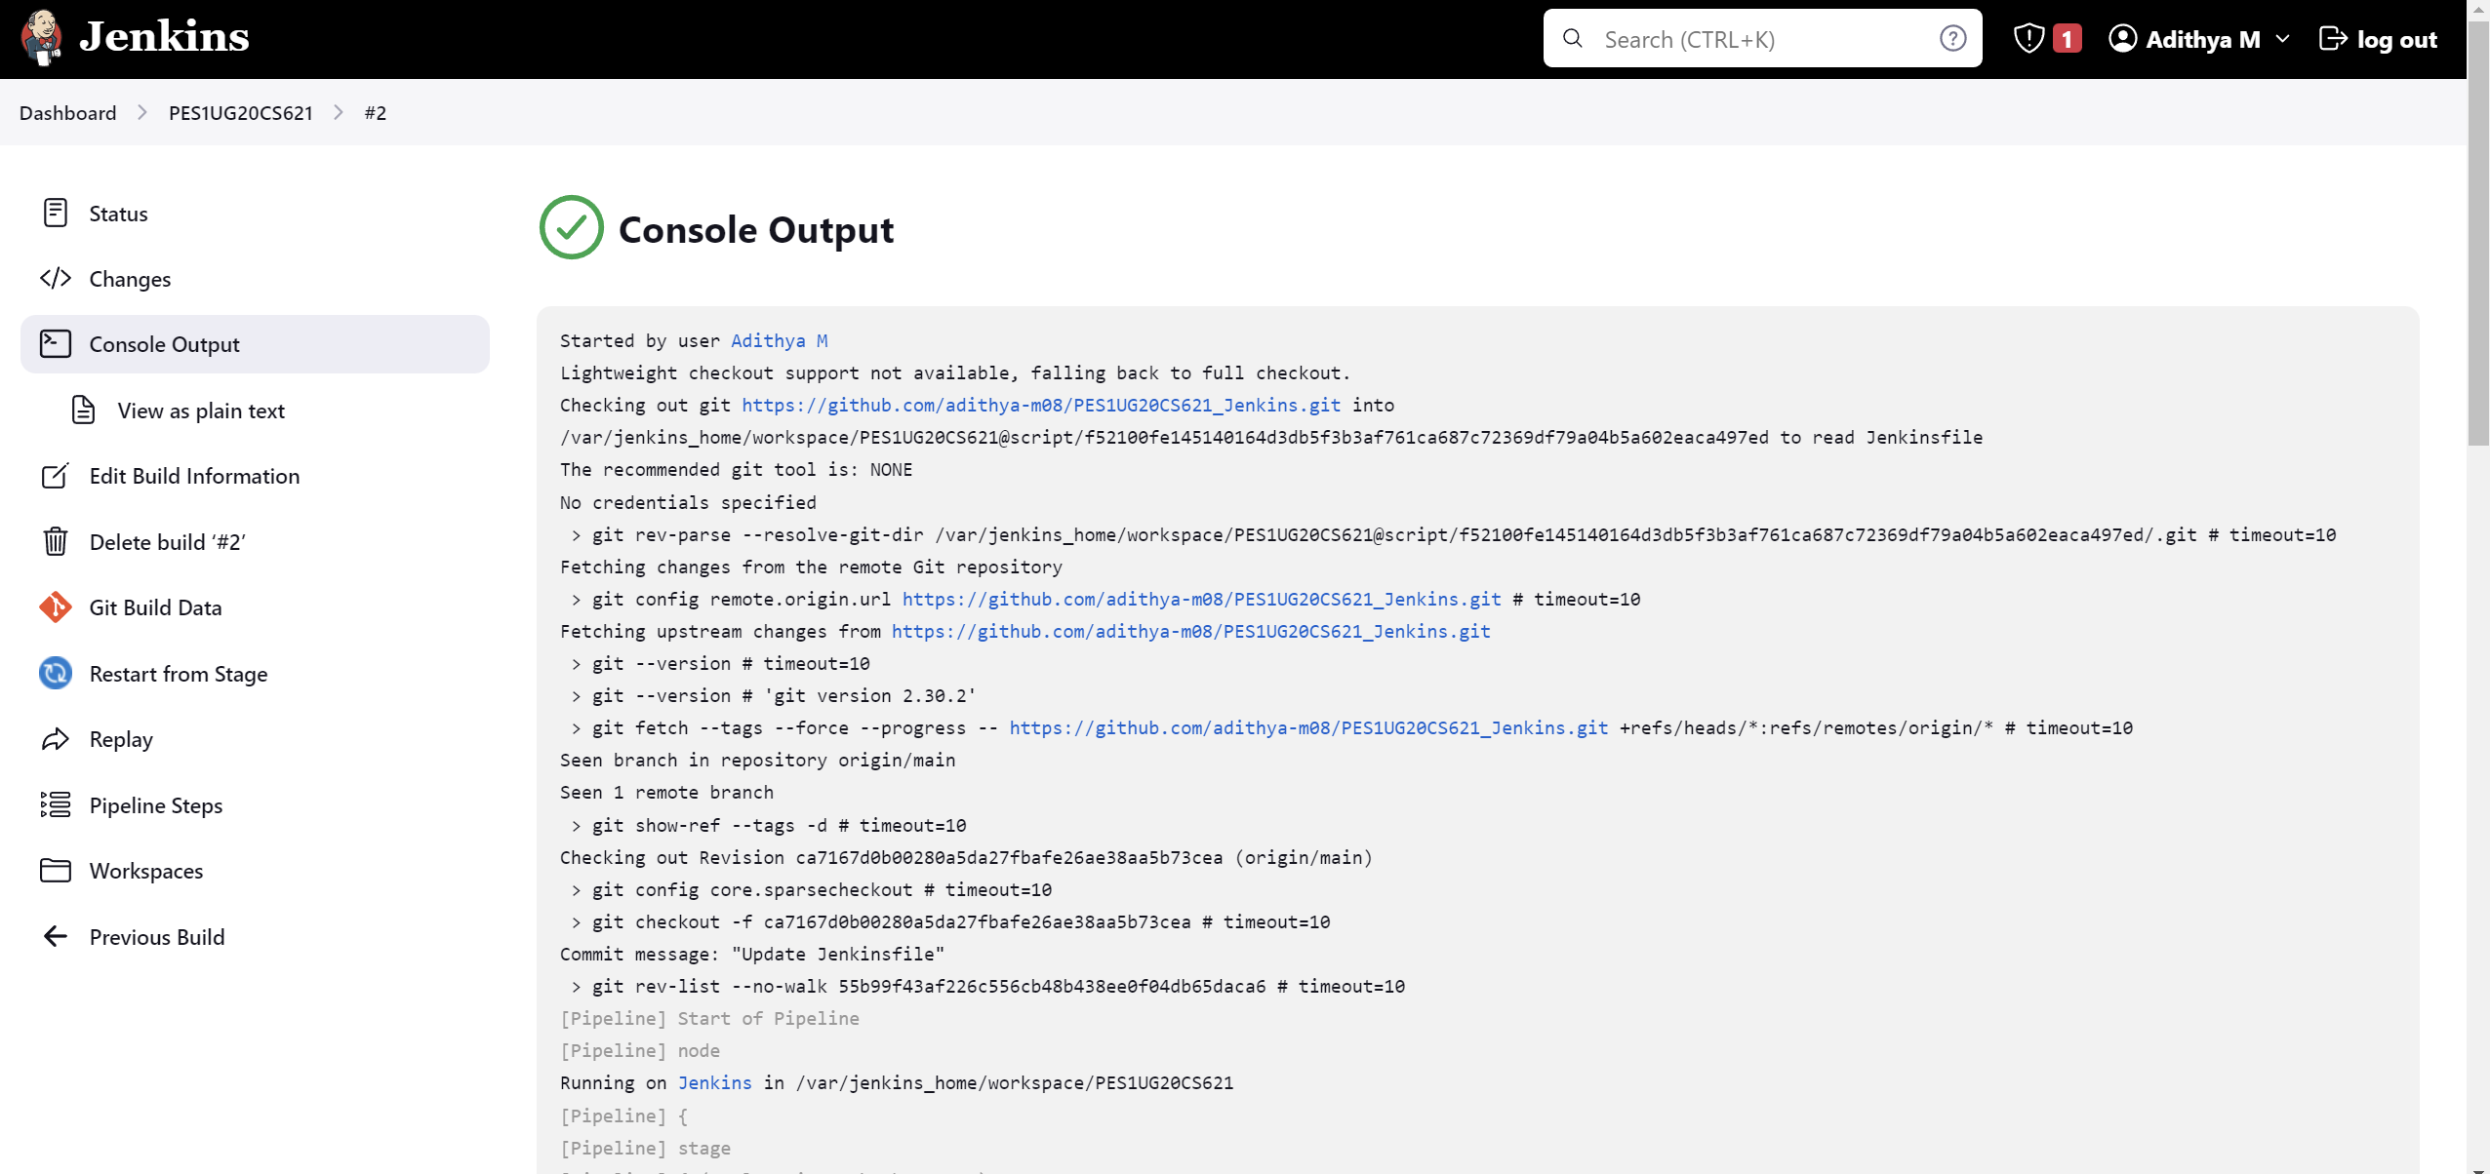

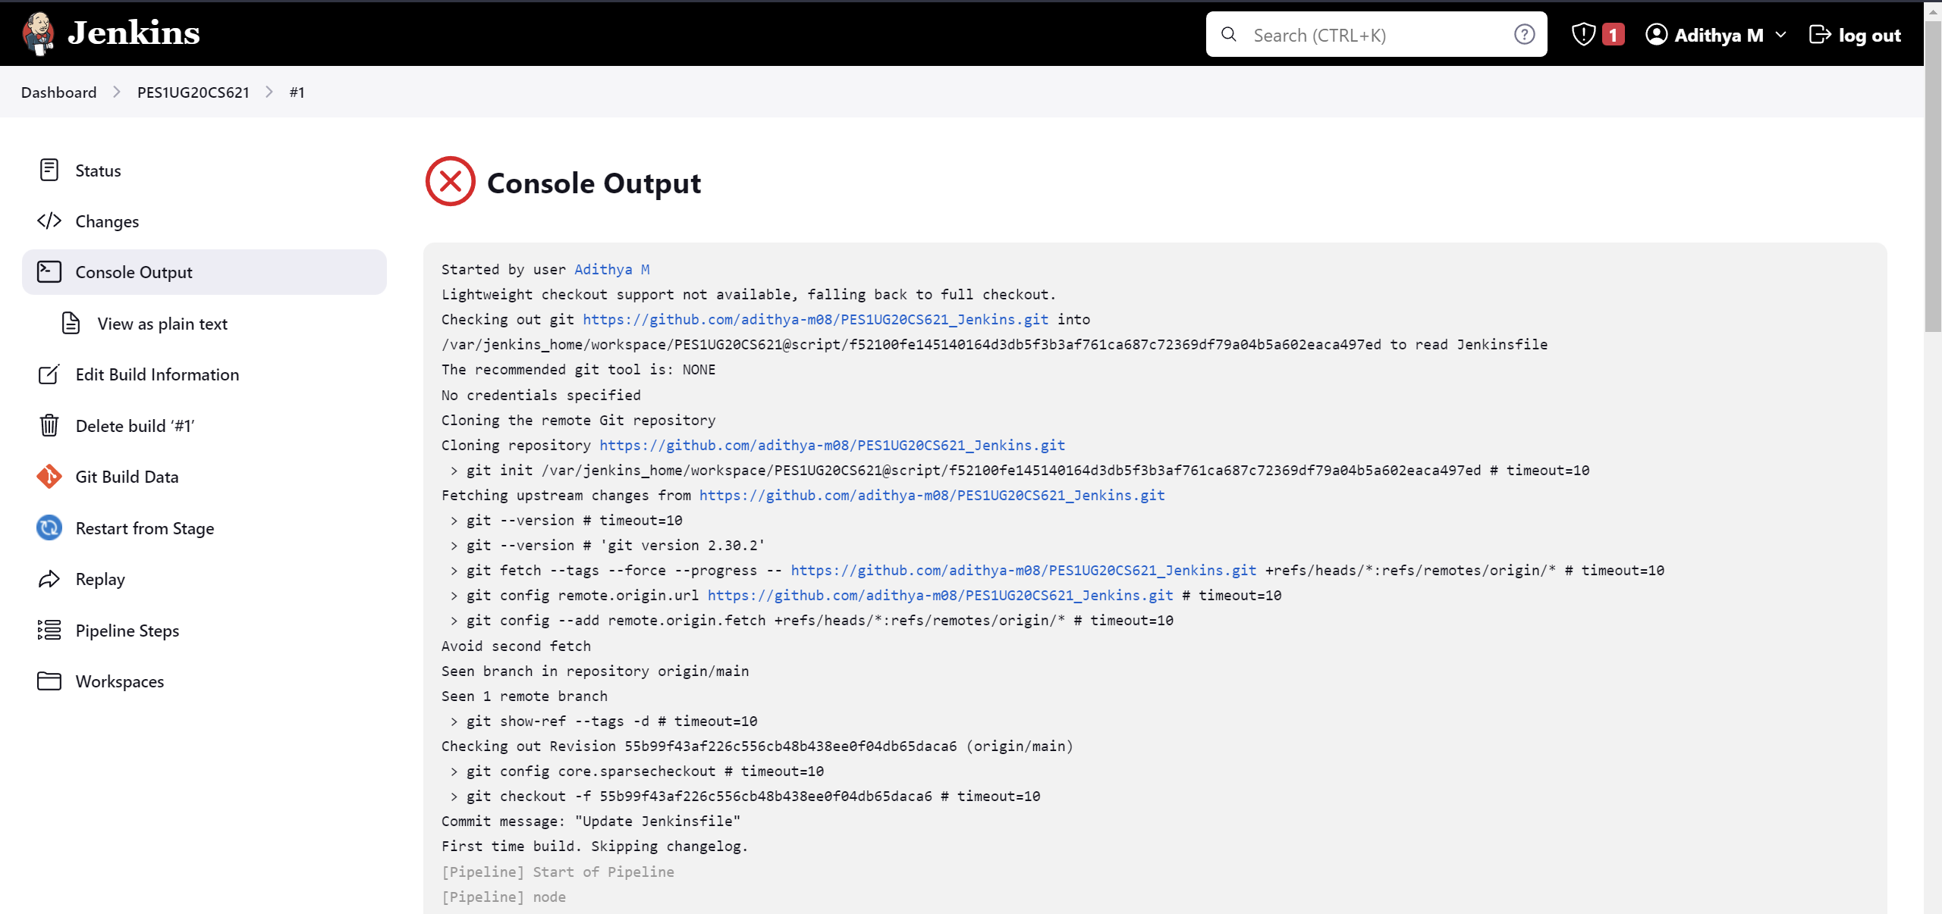

Link to repo: <https://github.com/adithya-m08/PES1UG20CS621_Jenkins.git>